DEVOPS CAPSTONE PROJECT-1

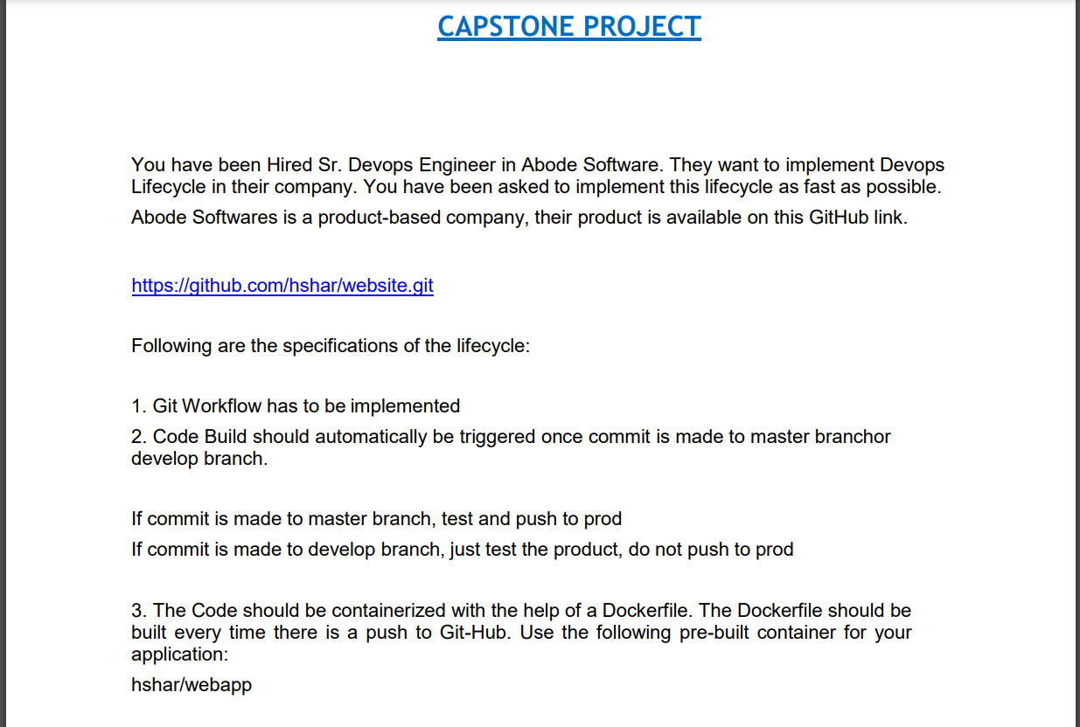

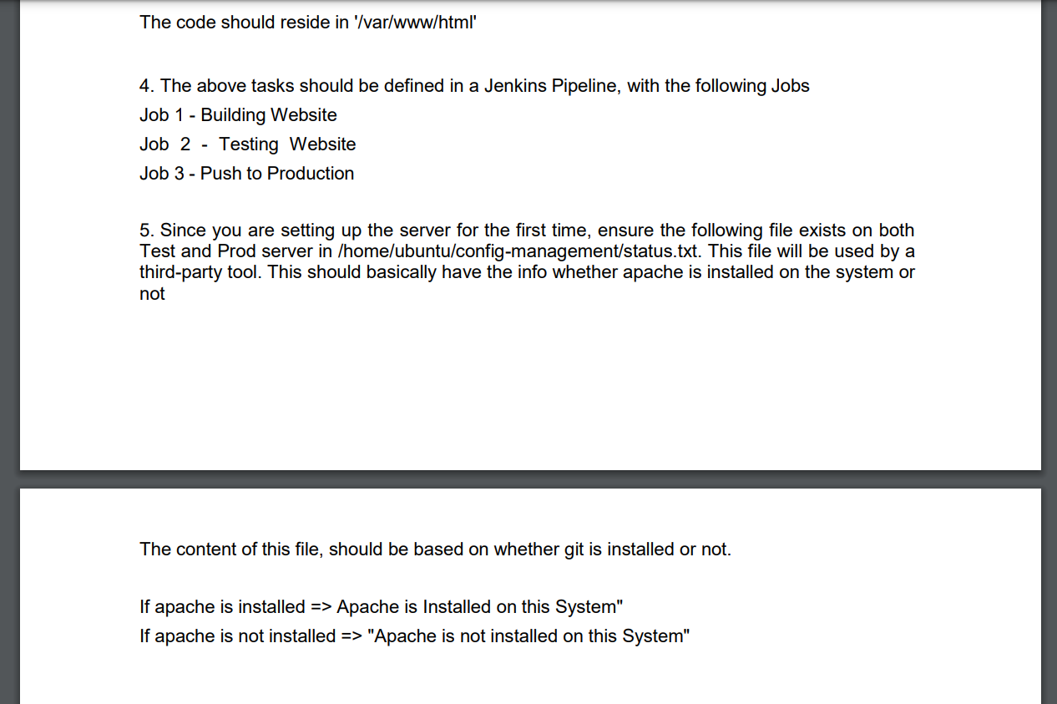

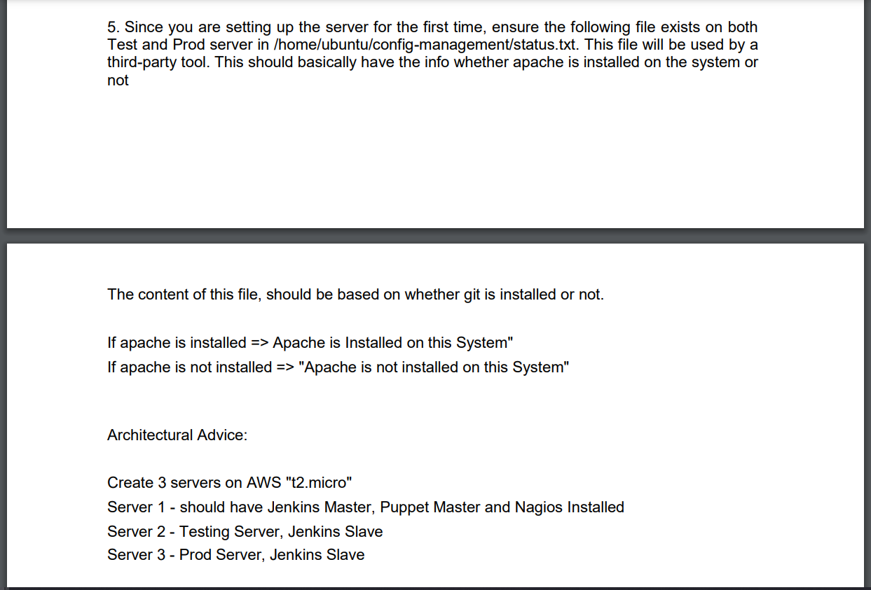

Solution:

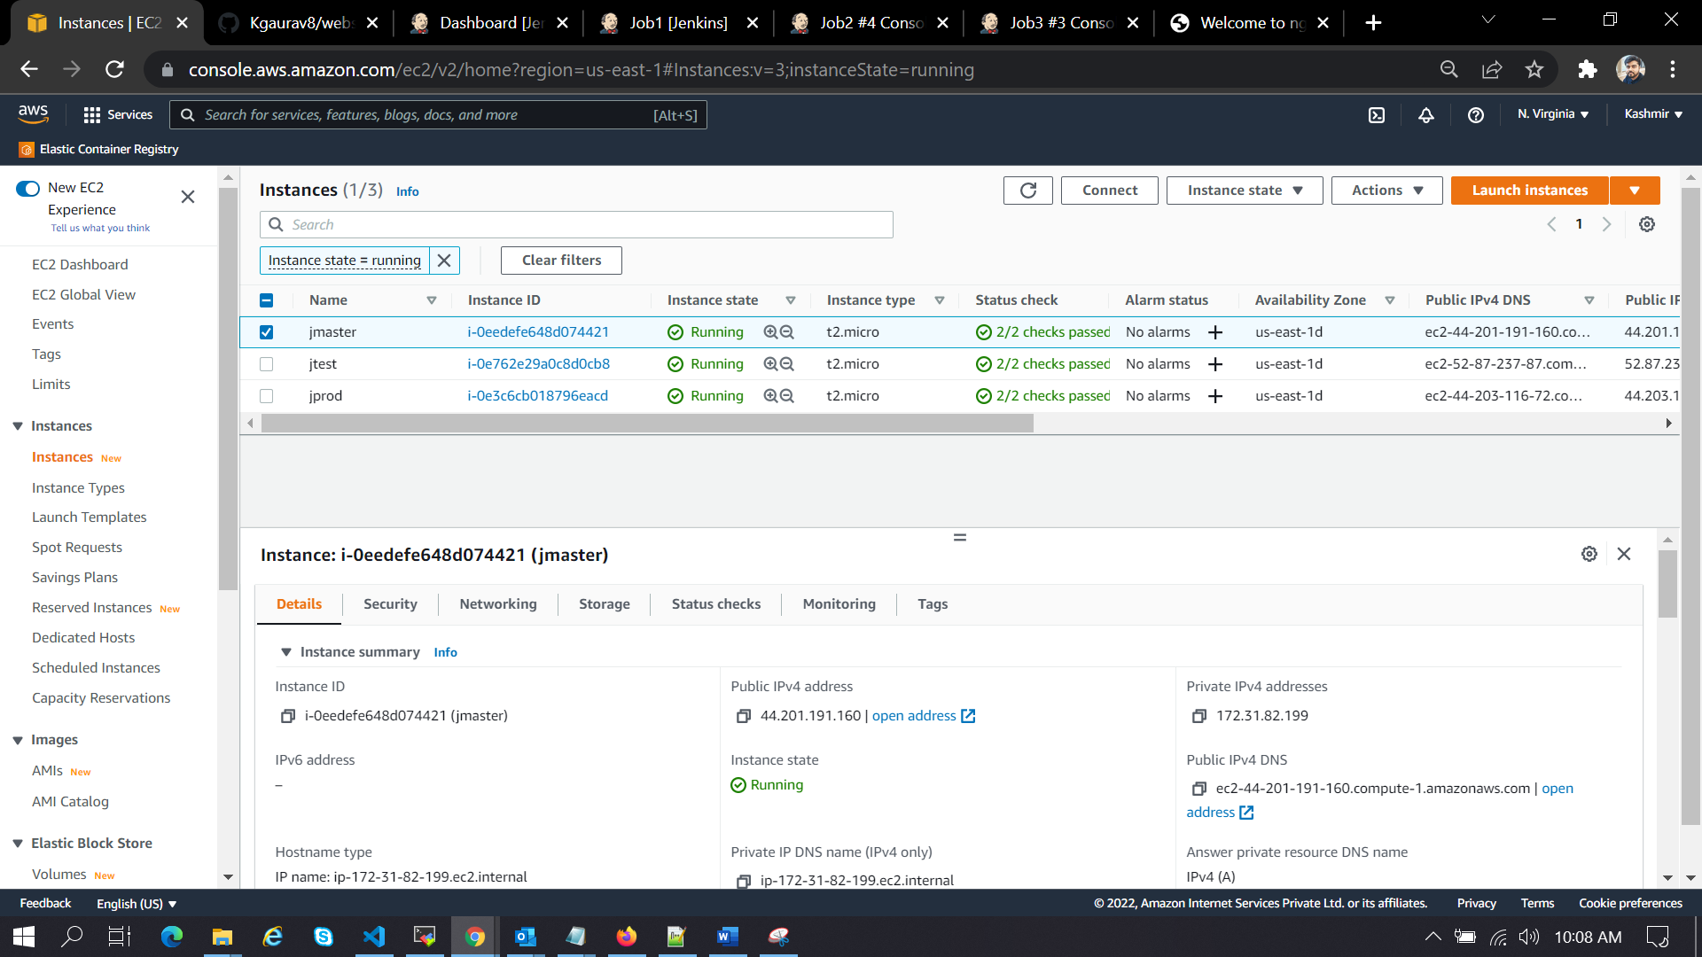

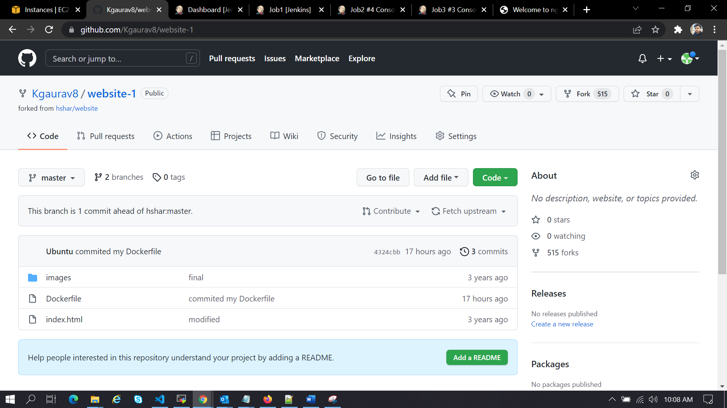

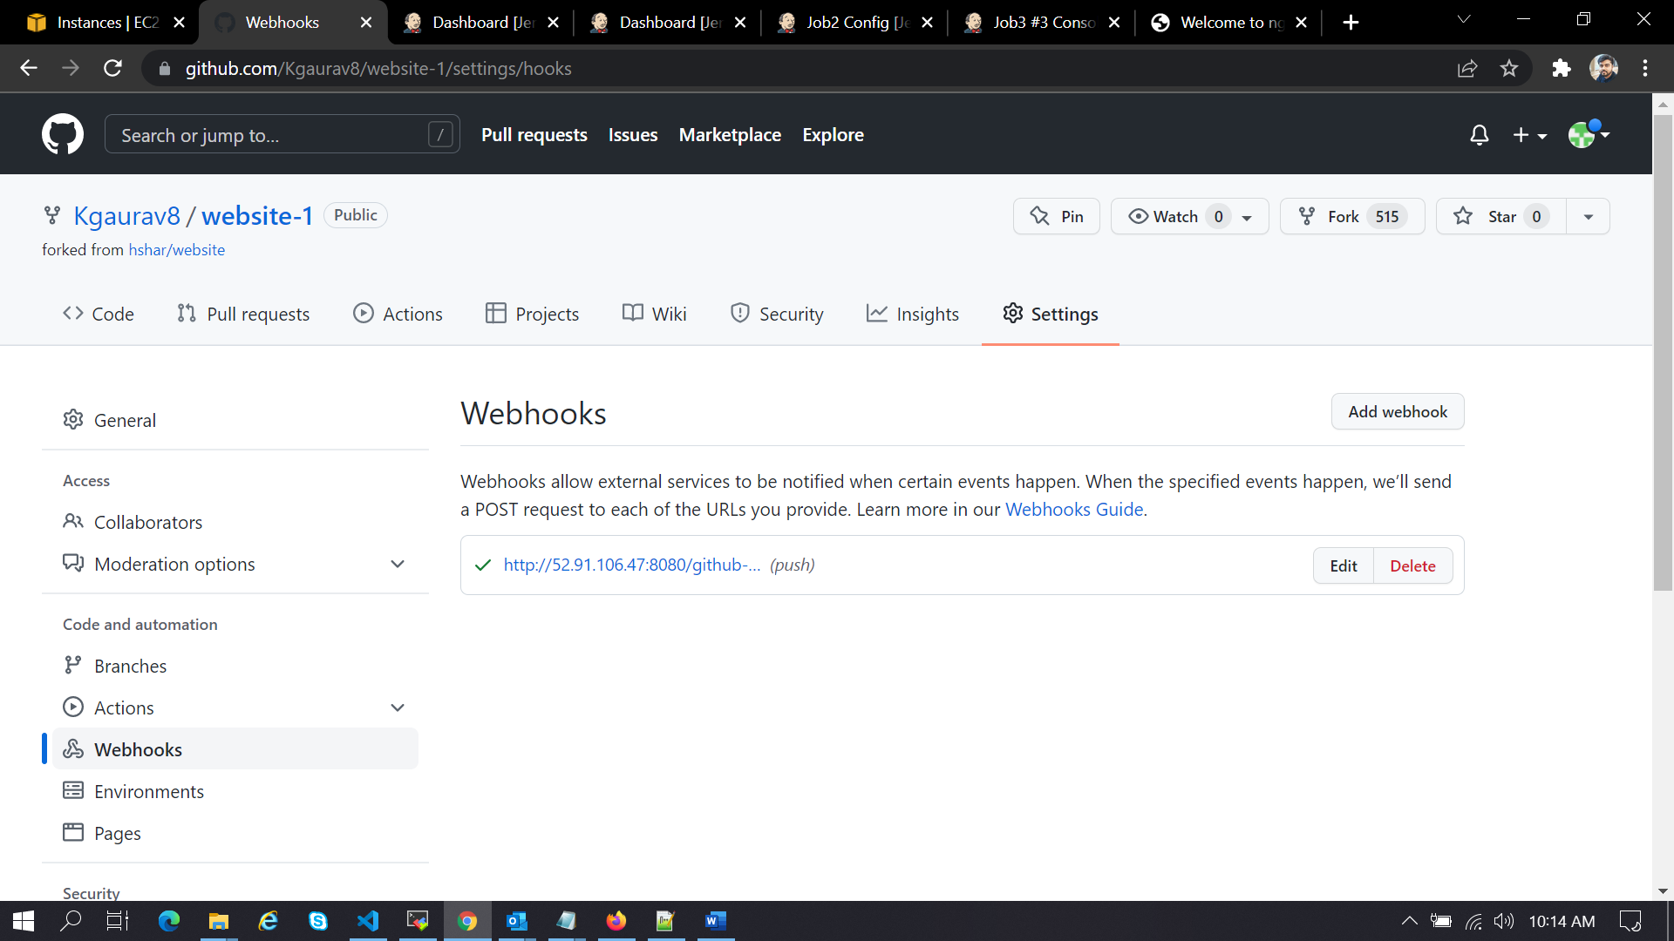

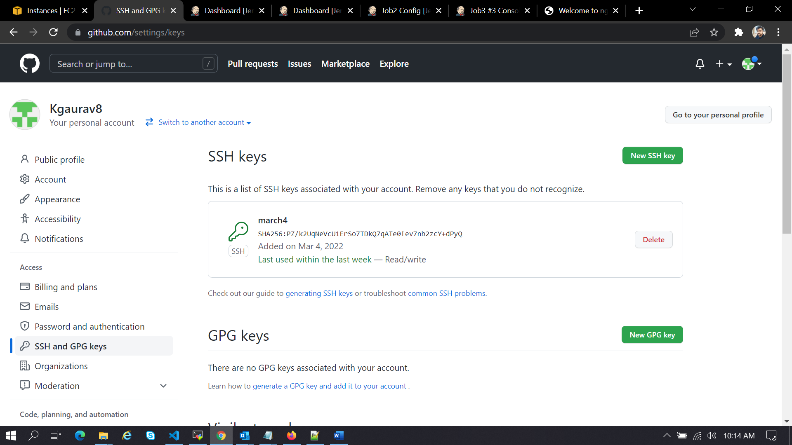

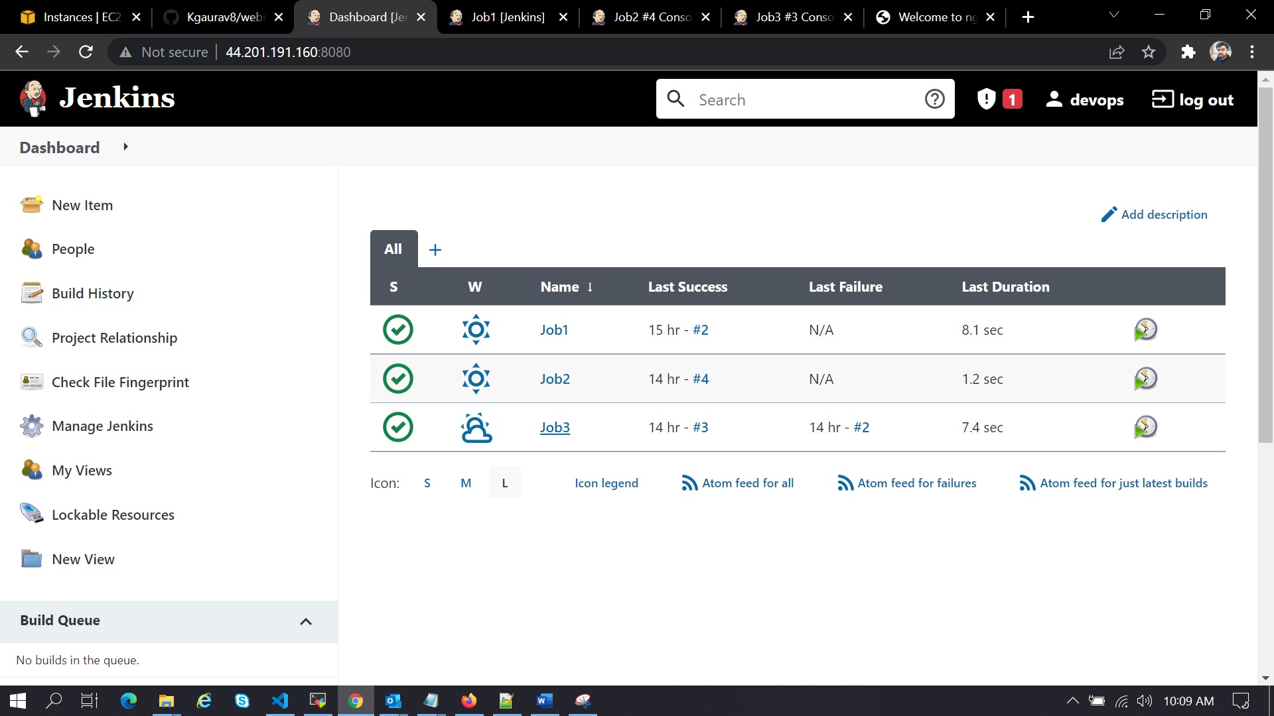

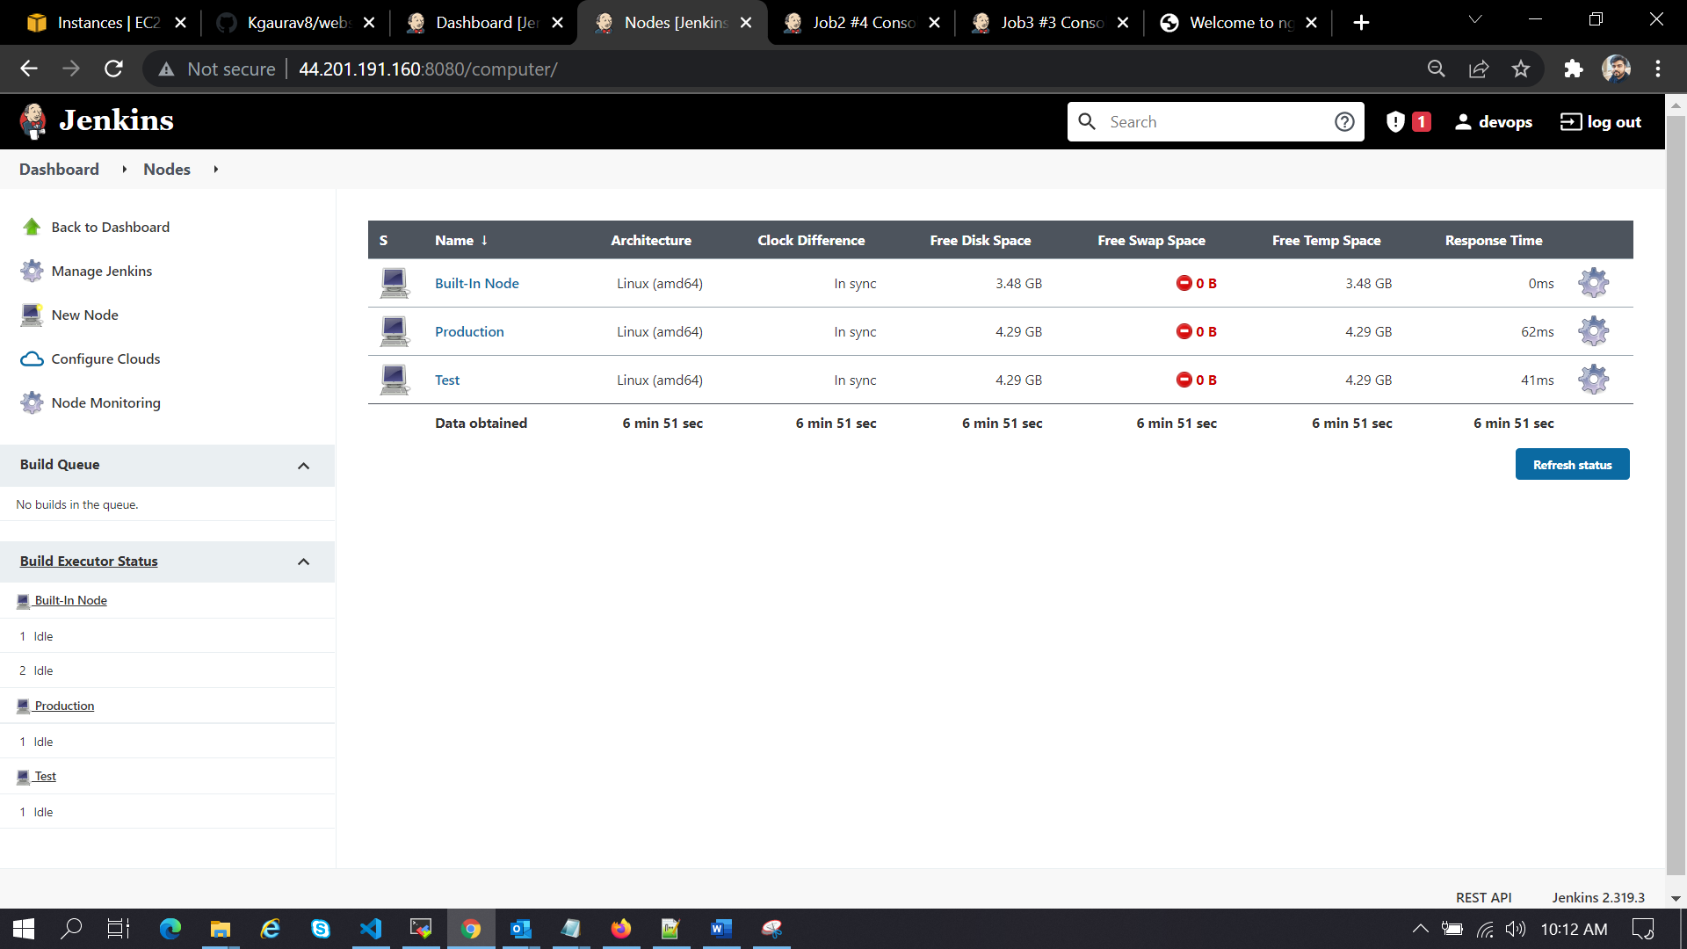

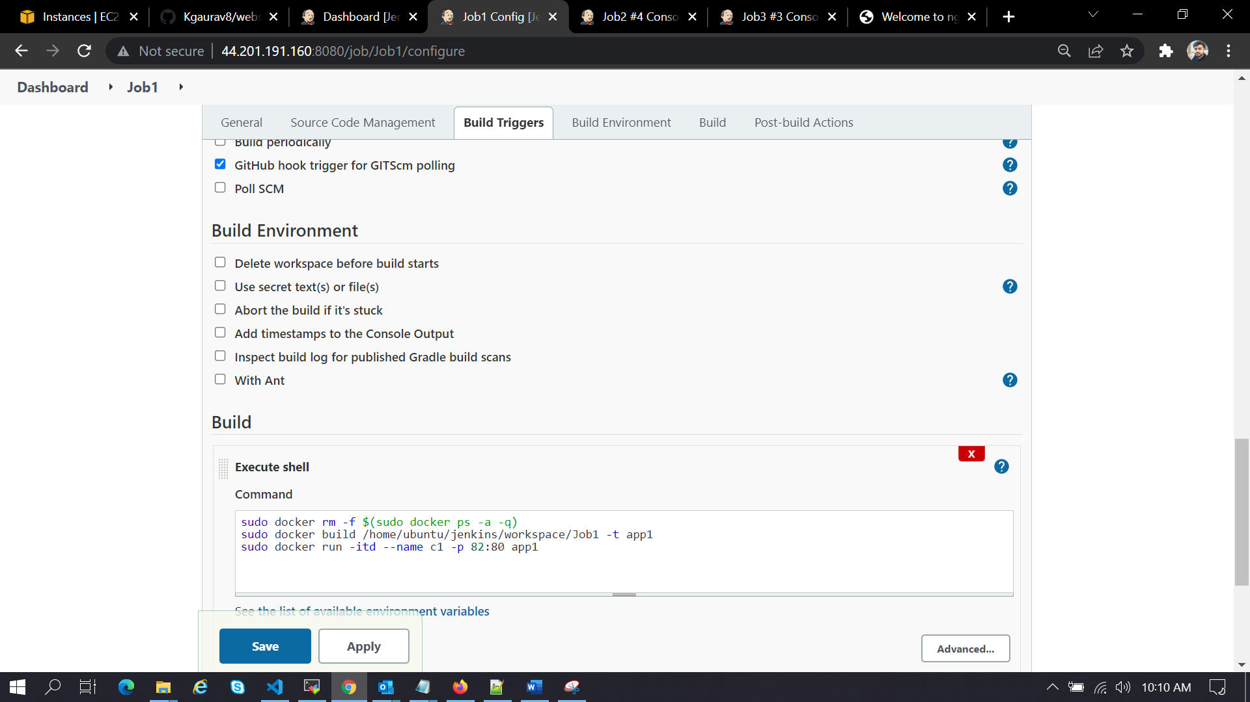

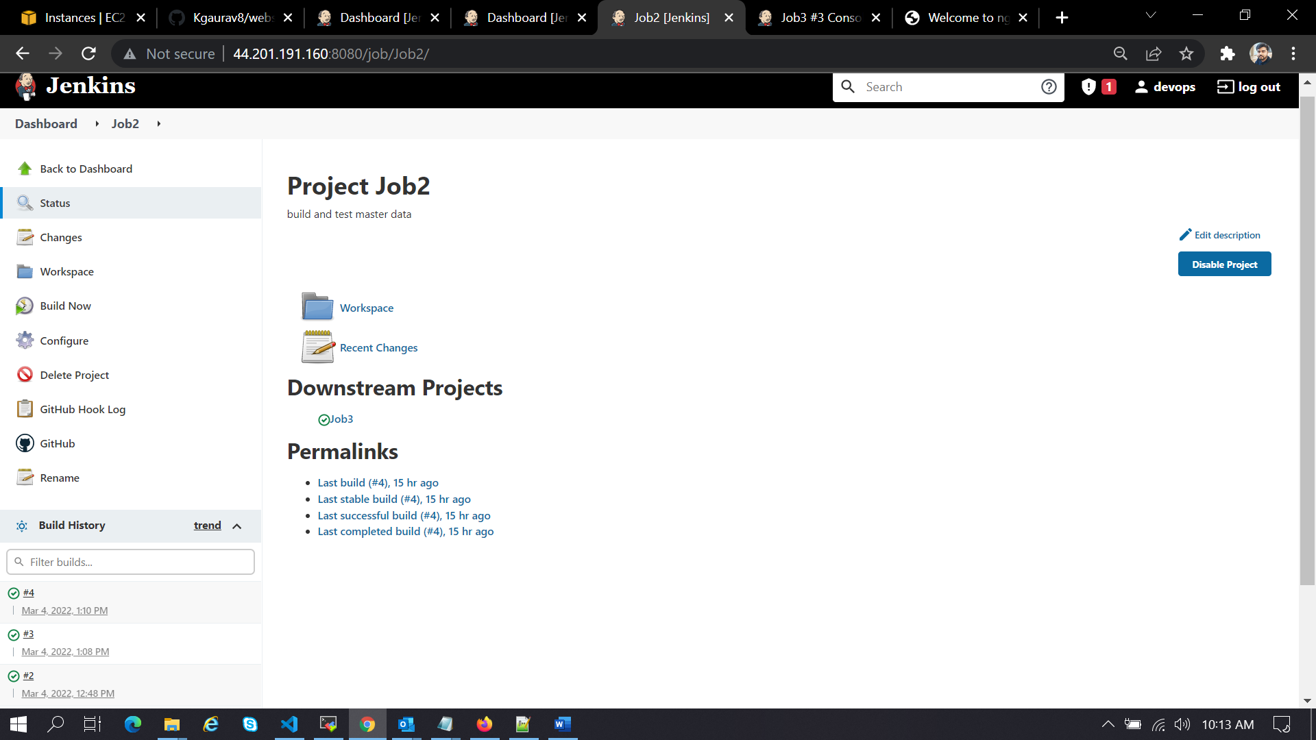

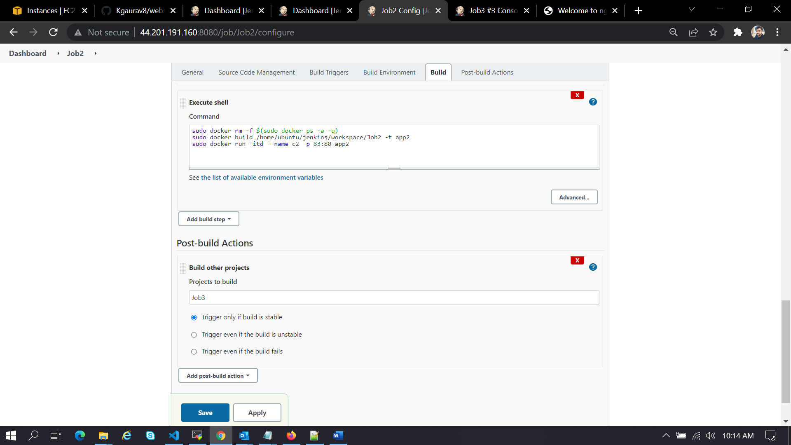

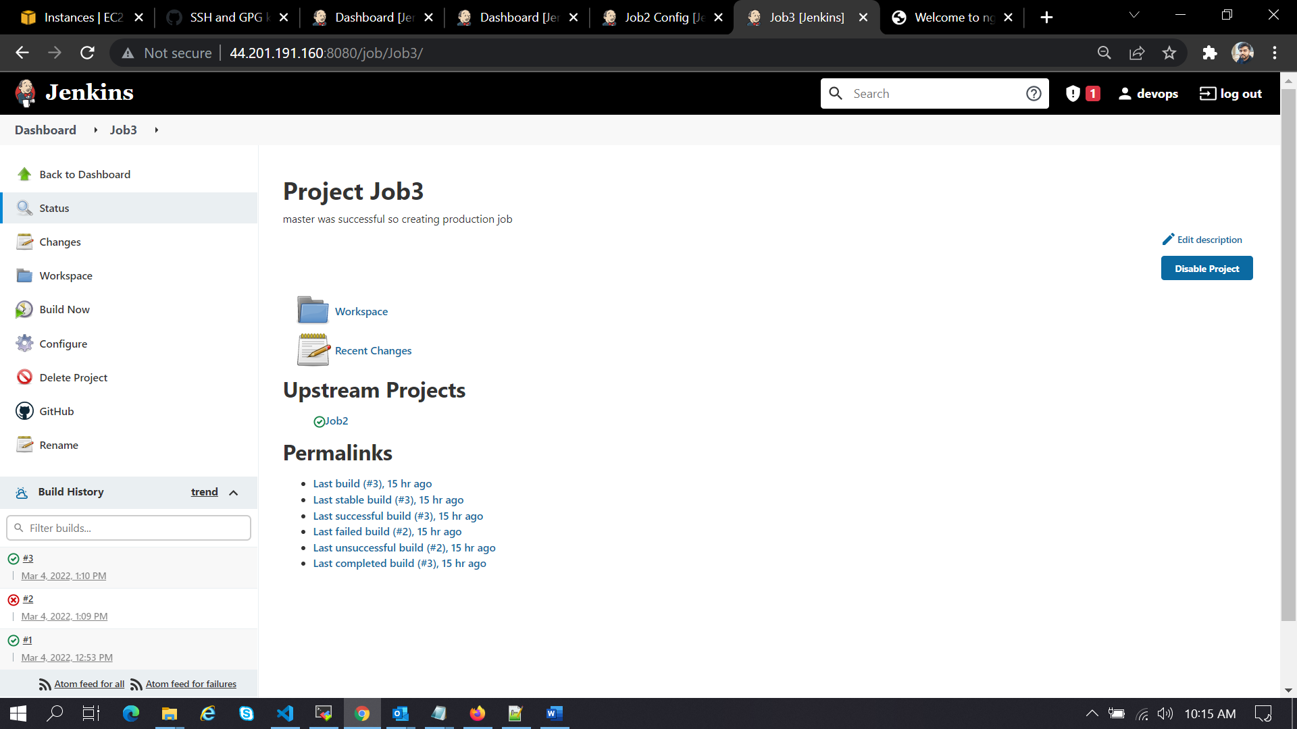

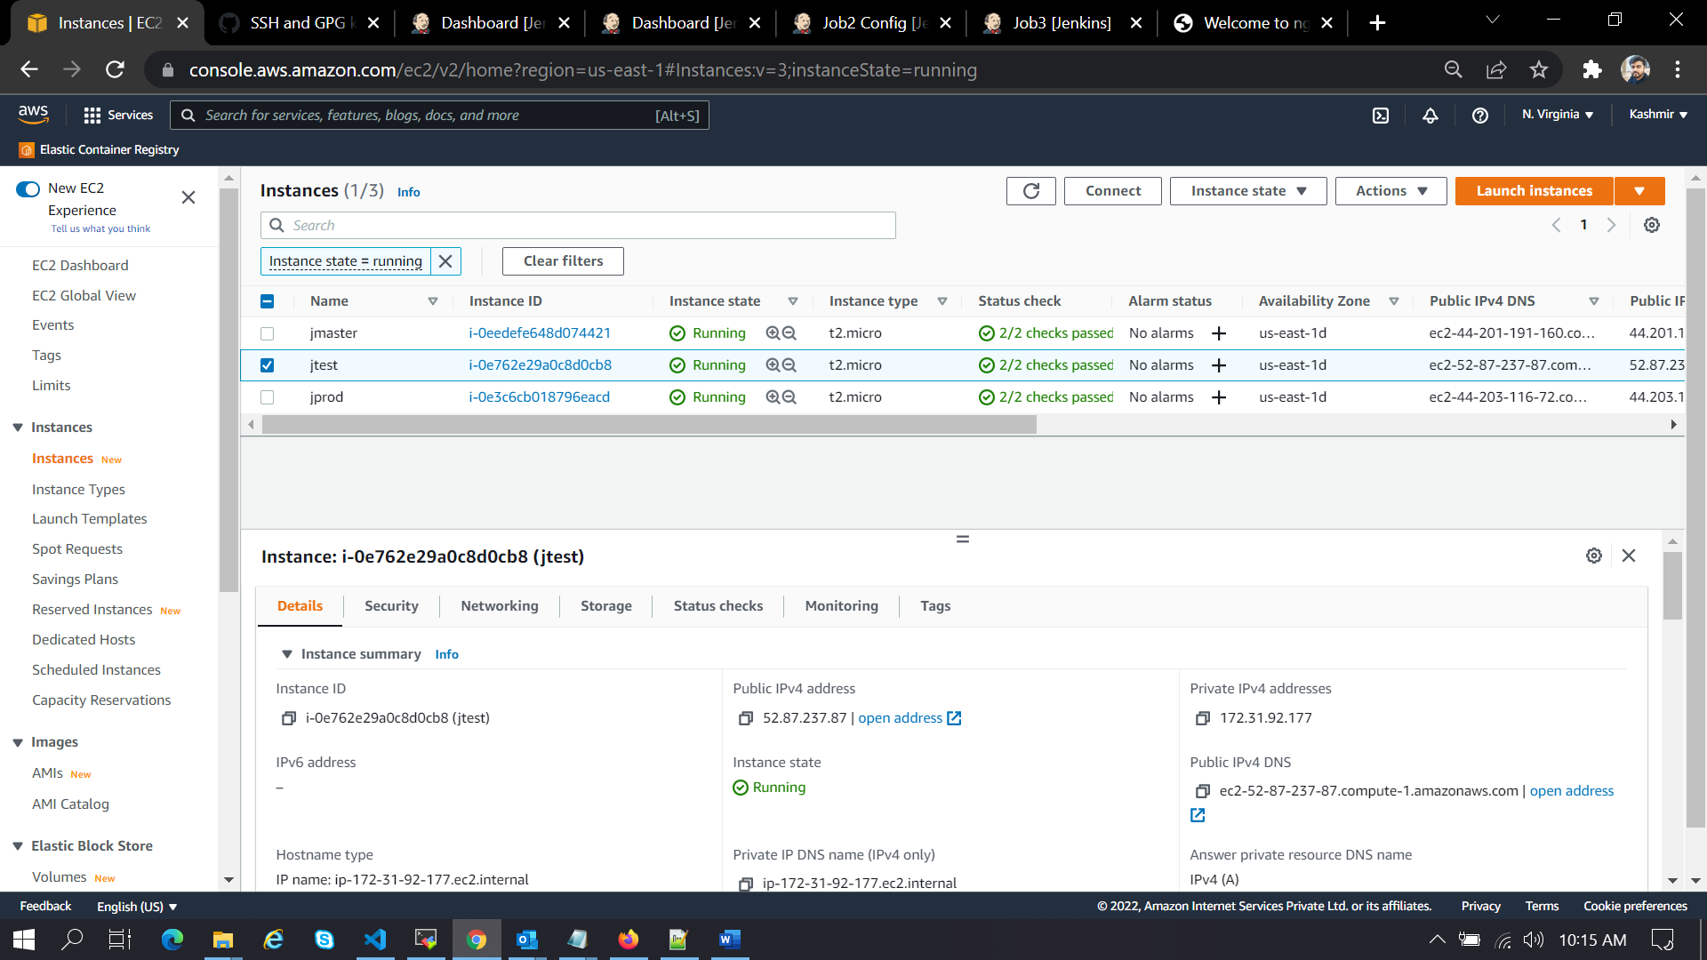

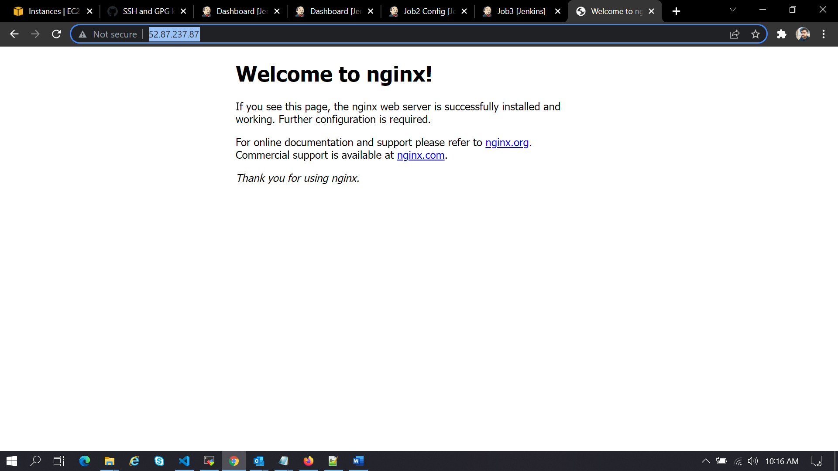

Commands Used:

ubuntu@ip-172-31-82-199:/etc/ansible$ history

1 clear

2 sudo apt-get update

3 sudo apt install ca-certificates

4 sudo apt-get install openjdk-11-jdk -y

5 wget -q -O - https://pkg.jenkins.io/debian-stable/jenkins.io.key | sudo apt-key add -

6 sudo sh -c 'echo deb https://pkg.jenkins.io/debian-stable binary/ > /etc/apt/sources.list.d/jenkins.list'

7 sudo apt-get update

8 sudo apt-get install jenkins -y

9 sudo apt-get install docker.io

10 systemctl status docker

11 ls

12 systemctl status jenkins

13 sudo apt-get install jenkins -y

14 jenkins

15 systemctl status jenkins

16 systemctl status docker

17 java -version

18 sudo cat /var/lib/jenkins/secrets/initialAdminPassword

19 cd .ssh

20 ls

21 ssh-keygen

22 ls

23 cat id_rsa.pub

24 cat id_rsa

25 cd

26 pwd

27 cd .ssh

28 ls

29 cat id_rsa.pub

30 cd

31 ls

32 git clone git@github.com:Kgaurav8/website-1.git

33 ls

34 cd website-1/

35 ls

36 sudo nano Dockerfile

37 git add .

38 git commit -m "commited my Dockerfile"

39 git branch

40 git push origin master

41 git branch develop

42 ls

43 git branch

44 git push origin develop

45 git branch

46 cd

47 sudo apt update

48 sudo apt install software-properties-common

49 sudo add-apt-repository --yes --update ppa:ansible/ansible

50 sudo apt install ansible

51 ls -lrt

52 cd /etc/

53 ls -lrt

54 cd ansible/

55 ls -lrt

56 sudo nano hosts

57 ansible -m ping all

58 cd roles/

59 sudo ansible-galaxy init role1

60 cd role1/

61 ls

62 cd tasks/

63 ls

64 sudo nano config.yml

65 clear

66 ls -lrt

67 cd website-1/

68 ls -lrt

69 cd /etc/ansible/

70 ls -lrt

71 sudo nano hosts

72 cd roles/

73 ls

74 sudo nano config.yml

75 ls -lrt

76 cd ..

77 ls -lrt

78 cd roles

79 ls -lrt

80 cd role1/

81 ll

82 cd tasks

83 ls

84 sudo nano config.yml

85 ls

86 sudo nano main.yml

87 cd ../../../

88 ls

89 sudo nano site.yml

90 ansible-playbook site.yml

91 clear

92 ls

93 cd /etc/ansible/

94 cd hosts

95 ll

96 cat hosts

97 ansible ping hosts -m all

98 ansible hosts ping -m all

99 cd

100 cd .ssh

101 ls

102 cat id_rsa.pub

103 cd

104 ansible -m ping all

105 systemctl status jenkins

106 ls -lrt

107* cd /etc/ansible/]

108 ls -lrt

109 cd roles/

110 ls -lrt

111 cd role1/

112 ls -lrt

113 cd tasks/

114 ls -lrt

115 cat config.yml

116 cd ../../../

117 cd roles/role1/tasks/

118 ls

119 cat main.yml

120 sudo main.yml

121 sudo nano main.yml

122 cd ../../../

123 ls -lrt

124 cat site.yml

125 sudo ansible site.yml

126 ansible-playbook site.yml

127 ls -lrt

128 sudo nano ansible.cfg

129 sudo nano site.yml

130 ansible-playbook site.yml

131 sudo nano ansible.cfg

132 ansible-playbook site.yml

